**Semester two**

**Insert School Logo**

**Examination, 2023**

**Question/Answer Booklet**

**HUMAN BIOLOGY**

**UNITS 1 & 2**

Name: Marking Key

Teacher: ______________________________________________________

**Time allowed for this paper**

Reading time before commencing work: ten minutes

Working time for the paper: three hours

**Materials required/recommended for this paper**

***To be provided by the supervisor***

This Question/Answer Booklet

Multiple-choice Answer Sheet

***To be provided by the candidate***

Standard items: pens (blue/black preferred), pencils (including coloured), sharpener, correction fluid/tape, eraser, ruler, highlighters

Special items: up to three calculators, which do not have the capacity to create or store programmes or text, are permitted in this ATAR course examination

**Important note to candidates**

No other items may be taken into the examination room. It is **your** responsibility to ensure that you do not have any unauthorised material. If you have any unauthorised material with you, hand it to the supervisor **before** reading any further.

**Structure of this paper**

|  |  |  |  |  |  |
| --- | --- | --- | --- | --- | --- |
| Section | Number of questions available | Number of questions to be answered | Suggested working time (minutes) | Marks available | Percentage of examination |
| Section One Multiple-choice | 30 | 30 | 40 | 30 | 30 |
| Section Two Short answer | 7 | 7 | 90 | 106 | 50 |
| Section Three Extended answer  Unit 1 | 2 | 1 | 50 | 20 | 10 |
| Unit 2 | 2 | 1 | 20 | 10 |
|  |  |  |  | **Total** | 100 |

**Instructions to candidates**

1. The rules for the conduct of the Western Australian examinations are detailed in the *Year 12 Information Handbook 2022: Part II Examinations*. Sitting this examination implies that you agree to abide by these rules.

2. Write your answers in this Question/Answer booklet preferably using a blue/black pen. Do not use erasable or gel pens.

3. Answer the questions according to the following instructions.

Section One: Answer all questions on the separate Multiple-choice answer sheet provided. For each question, shade the box to indicate your answer. Use only a blue or black pen to shade the boxes. Do not use erasable or gel pens. If you make a mistake, place a cross through that square, then shade your new answer. Do not erase or use correction fluid/tape. Marks will not be deducted for incorrect answers. No marks will be given if more than one answer is completed for any question.

Section Two: Write your answers in this Question/Answer booklet. Wherever possible, confine your answers to the line spaces provided.

Section Three: Consists of two parts each with two questions. You must answer one question from each part. Tick the box next to the question you are answering. Write your answers in this Question/Answer booklet

4. You must be careful to confine your answers to the specific questions asked and to follow any instructions that are specific to a particular question.

5. Supplementary pages for planning/continuing your answers to questions are provided at the end of this Question/Answer booklet. If you use these pages to continue an answer, indicate at the original answer where the answer is continued, i.e. give the page number.

**Section One: Multiple–choice 30% (30 Marks)**

This section has **30** questions. Answer **all** questions on the separate Multiple-choice answer sheet provided. For each question, shade the box to indicate your answer. Use only a blue or black pen to shade the boxes. Do not use erasable of gel pens. If you make a mistake, place a cross through that square, then shade your new answer. Do not erase or use correction fluid/tape. Marks will not be deducted for incorrect answers. No marks will be given if more than one answer is completed for any question.

Suggested working time: 40 minutes.

1. Which of the following components of blood plays an important role in protection against invading microorganisms?

(a) leucocytes

(b) erythrocytes

(c) plasma

(d) platelets

2. Which of the following is **not** a function of the lymphatic system?

(a) Carries excess tissue fluid that leaks out of cells.

(b) Carries leucocytes to aid in defence against disease.

(c) Contains lymph nodes for the production of erythrocytes.

(d) Empties fluid into large veins in the upper chest.

3. The platelets role in blood clotting is to

(a) form threads of insoluble protein called fibrin.

(b) release a fluid called serum.

(c) stick to the rough surface of the blood vessels.

(d) remove metabolic wastes from the clot.

4. Which of the following sexually transmitted infections (STIs) is caused by a virus?

(a) gonorrhoea

(b) chlamydia

(c) syphilis

(d) genital herpes

Questions 5 – 7 refer to the diagram below showing the structures within a human body cell.

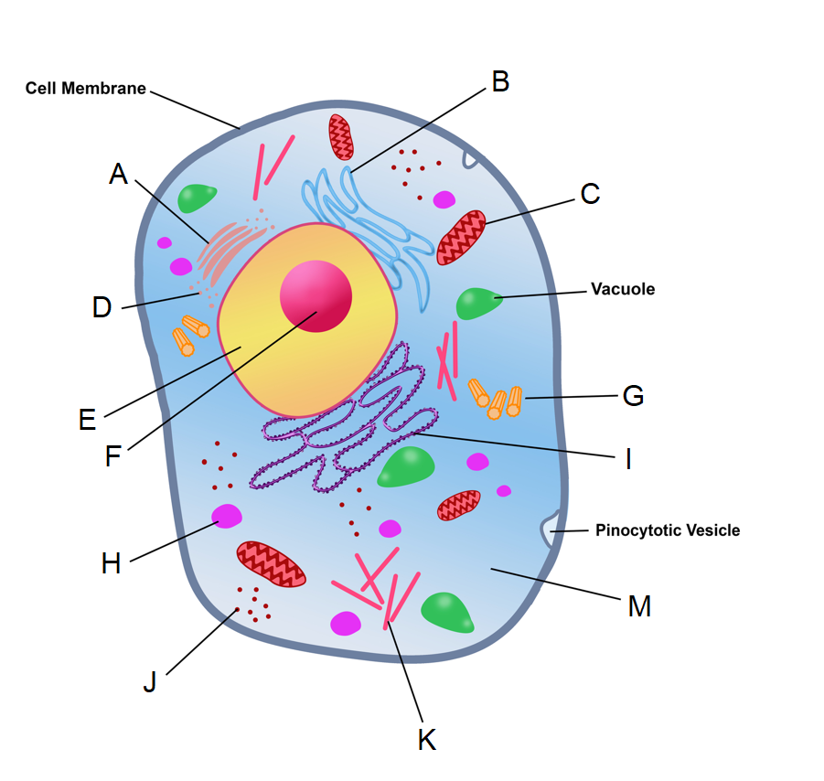

5. The structure labelled A is known as a

(a) Golgi apparatus.

(b) mitochondrion.

(c) centriole.

(d) microtubule.

6. The structures that form the spindle during mitosis and meiosis are indicated by which of the following labels?

(a) F

(b) J

(c) H

(d) G

7. Transcription takes place in which of the following parts?

(a) C

(b) E

(c) F

(d) M

8. The type of joint found where the humerus meets the ulna is best identified as a

(a) pivot joint.

(b) hinge joint.

(c) synovial joint.

(d) gliding joint.

9. Which of the following methods of assisted reproductive technologies (ART) would be most useful if there is a problem where the sperm cannot fertilise the egg unassisted?

(a) IVF

(b) GIFT

(c) IUI

(d) ICSI

10. Which of the following methods of contraception could be considered as a type of fertility awareness?

(a) the rhythm method

(b) coitus interruptus

(c) spermicides

(d) intrauterine devices

11. Which of the following structures is formed by the mesoderm during gestation?

(a) cartilage

(b) epithelium of the urinary bladder

(c) entire nervous system

(d) epidermis of the skin

12. A man with red-green colour blindness, a recessive condition caused by a mutated allele on the X chromosome, has children with a woman who is a carrier for the mutated allele. What is the probability they will have children with red-green colour blindness?

(a) 25%

(b) 50%

(c) 75%

(d) 100%

13. Fats, after digestion, are absorbed in the small intestine by

(a) simple diffusion into the blood capillaries.

(b) active transport into the blood capillaries.

(c) simple diffusion into the lacteals.

(d) active transport into the lacteals.

Questions 14 and 15 refer to the diagram below of a nephron.

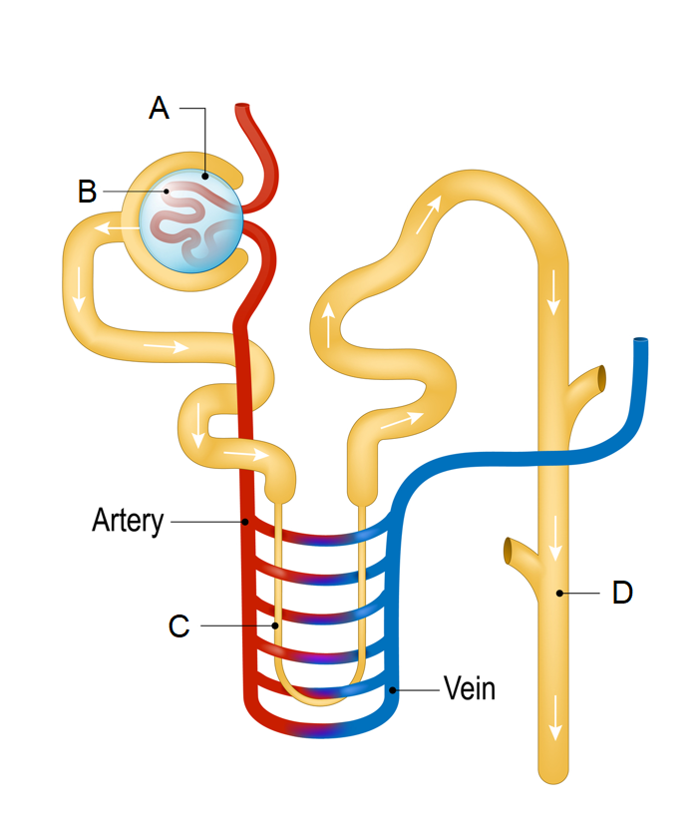

14. Which of the following processes occurs at the part labelled C?

(a) Active reabsorption of water.

(b) Secretion of hydrogen and potassium ions.

(c) Formation of filtrate.

(d) Passive reabsorption of water by osmosis.

15. Which of the following parts would have the highest concentration of glucose?

(a) A

(b) B

(c) C

(d) D

16. Mothers can help protect their unborn children from a condition called spina bifida by increasing their intake of which of the following nutrients during pregnancy?

(a) vitamin A

(b) calcium

(c) folic acid

(d) fluoride

17. The type of stem cells with the greatest level of potency are

(a) totipotent cells.

(b) pluripotent cells.

(c) multipotent cells.

(d) haemopoietic cells.

Questions 18 – 20 refer to the data shown in the table below.

**Table 1: Activity of the digestive enzyme pepsin as a percentage of its maximum**

|  |  |
| --- | --- |
| **pH** | **Activity of pepsin (%)** |
| 1.0 | 0 |
| 1.5 | 65 |
| 3.0 | 100 |
| 5.0 | 20 |
| 5.5 | 0 |

18. Which of the following could be considered a testable hypothesis for the experiment that generated this data?

(a) Pepsin works best in the stomach.

(b) The higher the pH, the greater the activity of pepsin.

(c) The activity of pepsin can be affected by pH levels.

(d) All digestive enzymes work best at a low pH.

19. This data could be transformed into a

(a) histogram.

(b) column graph.

(c) scatter plot.

(d) line graph.

20. Which of the following could affect the reliability of the experiment used to generate this data?

(a) Increasing the number of trials or sample size of the experiment.

(b) Changing the amount of pepsin used in each trial.

(c) The calibration of the equipment used to measure the activity of the pepsin.

(d) Changing the pH in each trial.

21. The enzyme that is used to unwind DNA during DNA replication is known as

(a) DNA polymerase.

(b) RNA polymerase.

(c) DNA helicase.

(d) DNA ligase.

22. DNA bound to proteins and found in the nucleus, in between cell divisions, is referred to as

(a) chromosomes.

(b) chromatin.

(c) chromatids.

(d) centromeres.

23. An increase in the concentration of a substrate in a chemical reaction

(a) will slow down the rate of reaction.

(b) will continually increase the rate of reaction.

(c) will initially increase rate of reaction until saturation occurs.

(d) will initially slow down rate of reaction until saturation occurs.

24. Multipotent stem cells can be found in

(a) the inner cell mass of a blastocyst.

(b) the trophoblast of a blastocyst.

(c) the morula.

(d) red bone marrow.

25. Which of the following correctly states the mode of inheritance for Huntington’s disease?

(a) X-linked, recessive

(b) autosomal, recessive

(c) X-linked, dominant

(d) autosomal, dominant

26. During inhalation

(a) the intercostal muscles relax, and pull the ribs up and out.

(b) the diaphragm relaxes, and increases the volume of the thoracic cavity.

(c) the intercostal muscles contract, and pull the ribs up and out.

(d) the diaphragm contracts, and decreases the volume of the thoracic cavity.

27. During menstruation, which of the following statements about hormones is correct?

(a) The levels of progesterone in the blood decrease, as the levels of FSH increase.

(b) The levels of progesterone in the blood increase, as the levels of FSH decrease.

(c) The levels of progesterone and FSH in the blood both increase.

(d) The levels of progesterone and FSH in the blood both decrease.

Questions 28 - 30 refer to the diagram below showing the digestive system.

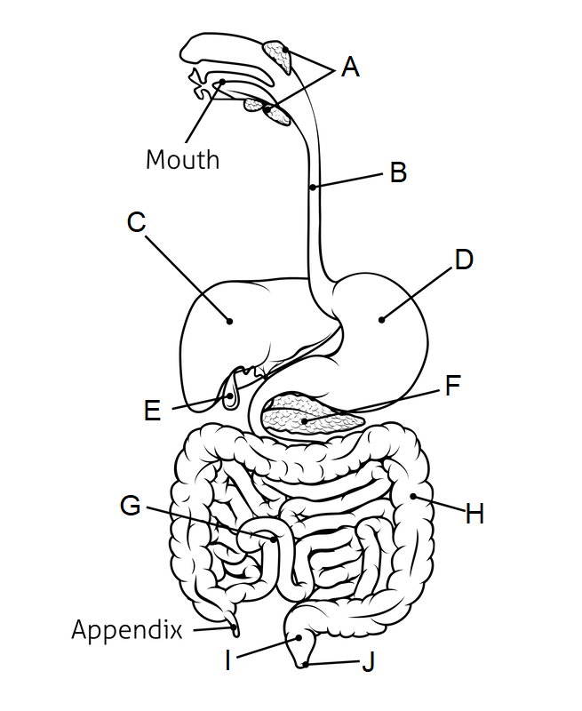

28. The part labelled F is the

(a) liver.

(b) stomach.

(c) pancreas.

(d) gall bladder.

29. Chemical digestion of proteins begins in

(a) the mouth.

(b) B.

(c) C.

(d) D.

30. Which of the following statements about bile is correct?

(a) It is produced in the part labelled C and breaks fats into tiny droplets.

(b) It is produced in the part labelled C and breaks fats into fatty acids and glycerol.

(c) It is produced in the part labelled E and breaks fats into tiny droplets.

(d) It is produced in the part labelled E and breaks fats into fatty acids and glycerol.

**End of Section One**

**Section Two: Short answer 50% (106 Marks)**

This section has **7** questions. Answer **all** questions. Write your answers in the spaces provided.

Supplementary pages for planning/continuing your answers to questions are provided at the end of this Question/Answer booklet. If you use these pages to continue an answer, indicate at the original answer where the answer is continued, i.e. give the page number.

Suggested working time: 90 minutes.

**Question 31 (15 marks)**

Crohn’s disease is a disease that effects the alimentary canal, most commonly the small intestine and the upper part of the large intestine.

(a) Contrast the structure of the small and large intestine. (2 marks)

|  |  |
| --- | --- |
| **Description** | **Marks** |
| Any two contrasting points from the following | |
| * The small intestine contains villi, the large intestine does not * The small intestine is longer, the large intestine is shorter * The small intestine has a smaller diameter compared to the large intestine | 1–2 |
| **Total** | **2** |

(b) During a flare up of Crohn’s the cells of the large intestinal wall may become inflamed and cannot function properly. Explain why this could lead to diarrhoea. (3 marks)

|  |  |
| --- | --- |
| **Description** | **Marks** |
| One role of the large intestine is to absorb water | 1 |
| If it cannot function the water is not absorbed | 1 |
| This leads to watery faeces = diarrhoea | 1 |
| **Total** | **3** |

(c) One function of the large intestine is storing faeces for elimination from the body. Describe how elimination differs from the process of excretion. (2 marks)

|  |  |
| --- | --- |
| **Description** | **Marks** |
| Elimination removes undigested material from the body | 1 |
| Excretion is the removal of metabolic wastes | 1 |
| **Total** | **2** |

Research into the cause of Crohn’s disease shows that it is a complex trait with an unclear pattern of inheritance, the best model suggests there is a major recessive allele that is responsible for a number of Crohn’s cases.

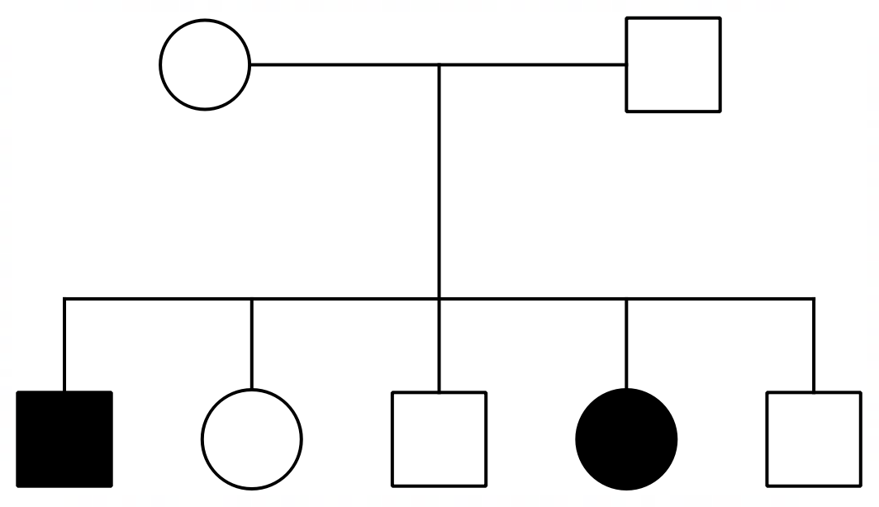The pedigree below shows the incidence of Crohn’s in a family, the shaded individuals have the disease.

(e) Explain, using evidence from the pedigree, why Crohn’s disease is autosomal and not X-linked. (3 marks)

|  |  |
| --- | --- |
| **Description** | **Marks** |
| An affected daughter has an unaffected father | 1 |
| If X-linked the father would definitely have the recessive condition (and be shaded) | 1 |
| Because he can’t be a carrier/heterozygous for the allele/can’t be heterozygous and mask the recessive allele | 1 |
| **Total** | **3** |

(f) State the genotype, using the letters ‘N’ and ‘n’, for the parents of the two affected children. (1 mark)

|  |  |
| --- | --- |
| **Description** | **Marks** |
| Nn | 1 |
| **Total** | **1** |

(g) If a female with no history of Crohn’s in her family decides to have children with the affected male in generation II, what is the probability of their child having Crohn’s disease? Justify your answer with use of a Punnett square. (4 marks)

|  |  |
| --- | --- |
| **Description** | **Marks** |
| 0% chance | 1 |
| If she has no history is likely homozygous – NN | 1 |
| All combinations of alleles for children the recessive allele from father is masked = no Crohn’s disease | 1 |
| Punnett square:   |  |  |  | | --- | --- | --- | |  | N | N | | n | Nn | Nn | | n | Nn | Nn | | 1 |
| **Total** | **4** |

**Question 32 (17 marks)**

The diagram below shows the structure of the cell membrane and the role of a carrier protein in the transport of water across the membrane.

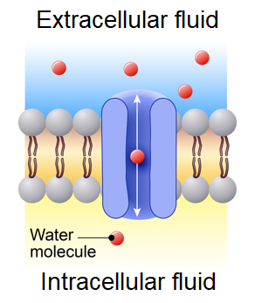

Hydrophobic tails

Hydrophilic head

Phospholipid molecule

(a) On the diagram, label a phospholipid molecule, a hydrophilic head and hydrophobic tails. (3 marks)

|  |  |
| --- | --- |
| **Description** | **Marks** |
| Labelled correctly, see diagram | 1-3 |
| **Total** | **3** |

(b) State whether the water molecules in the diagram will tend to move into the extracellular **or** intracellular fluid. (1 mark)

|  |  |
| --- | --- |
| **Description** | **Marks** |
| Intracellular fluid | 1 |
| **Total** | **1** |

(c) Explain your answer to part (b) using your knowledge of osmosis. (3 marks)

|  |  |
| --- | --- |
| **Description** | **Marks** |
| There is a higher concentration of water molecules in extracellular fluid | 1 |
| Water moves down a concentration gradient/from high to low concentration | 1 |
| Therefore enters the cell (where there are less water molecules) | 1 |
| **Total** | **3** |

(d) Explain why the water molecule cannot pass directly through the phospholipid bilayer.

(2 marks)

|  |  |
| --- | --- |
| **Description** | **Marks** |
| It is not lipid soluble/is a polar molecule | 1 |
| Cannot go through the membrane because the membrane is made up of lipids | 1 |
| **Total** | **2** |

Proteins, such as the channel proteins in the diagram, are coded for by genes found in the nucleus of the cell. They are then built at the ribosomes in the cytoplasm of the cell in a process called translation.

(e) Describe the process of translation. (3 marks)

|  |  |
| --- | --- |
| **Description** | **Marks** |
| Any 3 points from the following | |
| * The ribosome reads mRNA a codon at a time * tRNA molecule carry amino acid to mRNA * complementary anti-codon binds with codon * tRNA releases amino acid * peptide bonds form between amino acids (as process is repeated for each codon) | 1-3 |
| **Total** | **3** |

(f) Define epigenetics. (1 mark)

|  |  |
| --- | --- |
| **Description** | **Marks** |
| Any valid definition of epigenetics, linking changes in gene expression to factors **separate** from DNA, see examples below: | |
| * The study of changes in gene expression due to factors separate from the DNA * The study of changes in gene expression separate from DNA * The study of changes to gene expression without changes/alterations of the DNA sequence * Others… | 1 |
| **Total** | **1** |

(g) Describe how histone acetylation can lead to differences in gene expression. (4 marks)

|  |  |
| --- | --- |
| **Description** | **Marks** |
| Acetyl group can bind to histone tail | 1 |
| This relaxes or unwinds the chromatin | 1 |
| DNA is exposed and transcription promoted | 1 |
| Gene expression is enhanced/gene is switched on | 1 |
| **Total** | **4** |

**Question 33 (13 marks)**

Osteoporosis is a bone disease that is characterised by a loss of bony matrix, leading to a reduction in minerals in the bone, and therefore bone density.

One test to determine whether or not a person is suffering from osteoporosis compares the bone density of a healthy 30-year-old to the bone density of the person being tested. This process involves a statistical analysis known as a T-score, which can be roughly converted into a percentage of bone loss in comparison to a healthy 30-year-old.

The table below shows the T-scores and percentage bone loss for different age groups of women.

|  |  |  |
| --- | --- | --- |
| **Age group** | **T-score** | **\*Bone loss (%)** |
| 50 – 55 | - 0.6 | 6 |
| 60 – 65 | - 1.2 | 12 |
| 70 – 75 | - 1.9 | 19 |
| 80 - 85 | - 2.5 | 25 |

**\* in comparison to a healthy 30-year-old female**

(a) Construct a graph showing the bone loss, as a percentage, compared to age. (5 marks)

|  |  |
| --- | --- |
| **Description** | **Marks** |
| Appropriate title linking both axes | 1 |
| Both axes labelled and with units | 1 |
| Appropriate scale on y-axis | 1 |
| Correctly plotted histogram/column graph | 1 |
| Correctly organised with bone loss on y-axis | 1 |
|  | |
| **Total** | **5** |

(b) Describe the trend shown in the graph. (2 marks)

|  |  |
| --- | --- |
| **Description** | **Marks** |
| Any statement linking the independent and dependent variable, written as a trend.  Example: | |
| As age increases bone loss increases | 1-2 |
| **Total** | **2** |

(c) Osteoporosis primarily affects the spongy bone. Contrast the structure of spongy bone with compact bone. (3 marks)

|  |  |
| --- | --- |
| **Description** | **Marks** |
| Any 3 contrasting points from the following | |
| * Compact bone contains osteons, spongy bone does not/contains trabeculae * Spongy bone is porous, compact bone is more dense * Spongy bone contains red marrow, compact bone does not * Any other specific structural feature of an osteon compared to what’s in spongy bone | 1-3 |
| **Total** | **3** |

(d) Describe how sufferers of osteoporosis can manage/treat the condition and outline how this condition can be prevented. (3 marks)

|  |  |
| --- | --- |
| **Description** | **Marks** |
| Treat/manage the condition | |
| Can be treated by increasing calcium intake/vitamin D | 1 |
| Appropriate weight bearing exercises to increase bone density | 1 |
| Prevent condition (any **one** point from the following): | |
| * Adequate calcium and vitamin D * Exercise * Reduce smoking (or any other relevant risk factor) | 1 |
| **Total** | **3** |

**Question 34 (15 marks)**

The diagram below shows the processes of spermatogenesis and oogenesis.

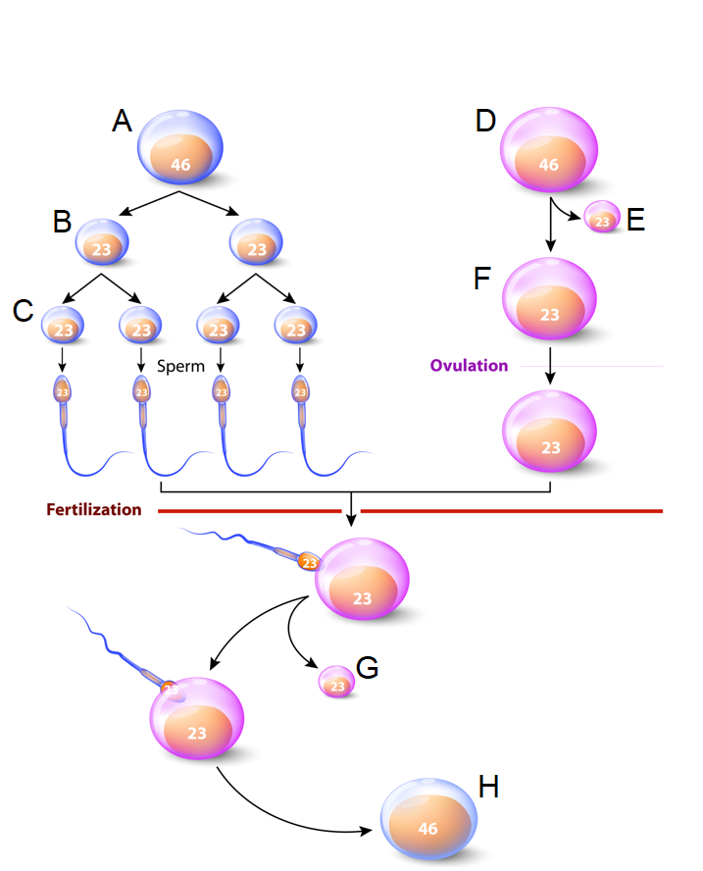

(a) Complete the table below, identifying the structures from the diagram above.

(3 marks)

|  |  |
| --- | --- |
| **Description** | **Marks** |
| A – primary spermatocyte | 1 |
| E – first polar body | 1 |
| H – zygote | 1 |
| **Total** | **3** |

(b) Describe what ovulation refers to and name the hormone that triggers this process.

(2 marks)

|  |  |
| --- | --- |
| **Description** | **Marks** |
| When the egg/secondary oocyte is released from the ovary | 1 |
| Luteinising hormone/LH | 1 |
| **Total** | **2** |

(c) Explain how the structure of sperm suits their function. (4 marks)

|  |  |
| --- | --- |
| **Description** | **Marks** |
| Any **two** of the following pairs of points, including the description of the structure and an explanation for why this helps with the function: | |
| Presence of tail allows for movement  So sperm can travel to the fallopian tube/reach distance to fallopian tube | 1-2 |
| Acrosome/head has enzymes  To allow them to break down the structures surrounding egg/breakdown zona pellucida | 1-2 |
| Mitochondria present in the middle/neck region  Allows for energy production/release to sperm can travel distance/use tail | 1-2 |
| **Total** | **4** |

(d) Explain how the process of fertilisation can determine the sex of the offspring. (4 marks)

|  |  |
| --- | --- |
| **Description** | **Marks** |
| The sperm can contain either an X chromosome or Y chromosome/can contain one of two different sex chromosomes | 1 |
| The ovum only contains one type of sex chromosome/has only and X sex chromosome | 1 |
| Whichever of the two sex chromosomes is in the sperm will determine the sex of the offspring | 1 |
| At fertilisation when sex chromosomes pair up this will determine male - XY or female XX | 1 |
| **Total** | **4** |

(e) State **two** processes that occur during meiosis that can also lead to variation in the genotypes of offspring. (2 marks)

|  |  |
| --- | --- |
| **Description** | **Marks** |
| Any 2 from the following | |
| * Random/independent assortment * Crossing over * Non-disjunction | 1-2 |
| **Total** | **2** |

**Question 35 (15 marks)**

Blood transfusions can save lives, and is a helpful procedure for patients with severe infection, some types of blood disorders and when there is an extreme loss of blood due to accident or injury.

For cases involving extreme blood loss the goal of a blood transfusion is primarily linked to the replacement of erythrocytes.

(a) Describe the structure of erythrocytes. (2 marks)

|  |  |
| --- | --- |
| **Description** | **Marks** |
| Any 2 points from the following | |
| * Biconcave disc * Lacking a nucleus * Contains haemoglobin * Other… | 1-2 |
| **Total** | **2** |

(b) Describe the function of erythrocytes in the transport of gases. (3 marks)

|  |  |
| --- | --- |
| **Description** | **Marks** |
| Haemoglobin can combine with oxygen and carbon dioxide | 1 |
| To form oxyhaemoglobin/97% of oxygen bonds with haemoglobin | 1 |
| To form carbaminohaemoglobin/23% of CO2 bonds with haemoglobin | 1 |
| **Total** | **3** |

(c) Describe the Rhesus blood grouping system. (2 marks)

|  |  |
| --- | --- |
| **Description** | **Marks** |
| The rhesus factor is an antigen found on red blood cells | 1 |
| Someone with the antigen will be Rh-positive and without will be Rh-negative | 1 |
| **Total** | **2** |

(d) If someone is positive for the Rhesus factor, can they donate to someone who is negative? Explain your answer. (3 marks)

|  |  |
| --- | --- |
| **Description** | **Marks** |
| No | 1 |
| Because Rh antigen will cause production of antibodies/an immune response/lead to clumping of erythrocytes | 1 |
| Because the immune system of the person who is Rh negative will recognise the antigen as foreign/similar response | 1 |
| **Total** | **3** |

(e) The ABO blood grouping system is based on inheritance through genetics and is determined by multiple alleles.

(i) Describe what is meant by a pattern of inheritance that is determined through multiple alleles. (1 mark)

|  |  |
| --- | --- |
| **Description** | **Marks** |
| More than two different/alternative forms of a gene that code for a certain characteristic | 1 |
| **Total** | **1** |

(ii) Determine, with the use of a Punnett square, whether it is possible for two people with type A blood to have a child with type O. Include an explanation with your Punnett square. (4 marks)

|  |  |
| --- | --- |
| **Description** | **Marks** |
| There is a 25% chance | 1 |
| If both type A are heterozygous | 1 |
| Then each can pass down a recessive allele to their offspring | 1 |
| Punnett square:   |  |  |  | | --- | --- | --- | |  | IA | i | | IA | IAIA | IAi | | i | IAi | ii | | 1 |
| **Total** | **4** |

**Question 36 (16 marks)**

Skeletal muscles often work together to allow for articulation at a synovial joint, each type of muscle playing an important role in each differing movement.

(a) Describe what is meant by antagonistic pairs of muscles, using an example in the human body to aid your answer. (3 marks)

|  |  |
| --- | --- |
| **Description** | **Marks** |
| Pairs of muscles that work together | 1 |
| One is the prime mover, the other is the antagonist | 1 |
| Examples (one of the following **pairs** or other relevant answers):  Biceps & triceps  Hamstrings and quadriceps | 1 |
| **Total** | **3** |

(b) Explain the importance of a fixator muscle when performing a particular movement at a synovial joint. (2 marks)

|  |  |
| --- | --- |
| **Description** | **Marks** |
| Steady a joint during a particular movement | 1 |
| Allowing one part of the body to perform a movement while another remains stable/fixed | 1 |
| **Total** | **2** |

(c) Explain how the sliding filament theory allows for muscle contraction. (4 marks)

|  |  |
| --- | --- |
| **Description** | **Marks** |
| When muscles contract, the sarcomeres shorten | 1 |
| This happens because the actin and myosin slide over each other | 1 |
| * Calcium enters the sarcoplasmic reticulum. * Calcium binds to troponin and change shape of tropomyosin * The myosin attaches to the actin/forms a cross-bridge with actin * ATP (ADP +P) is released and a power stroke pulls the actin * This brings Z-lines together | 1-2 |
| **Total** | **4** |

The diagram below shows the general structure of a synovial joint.

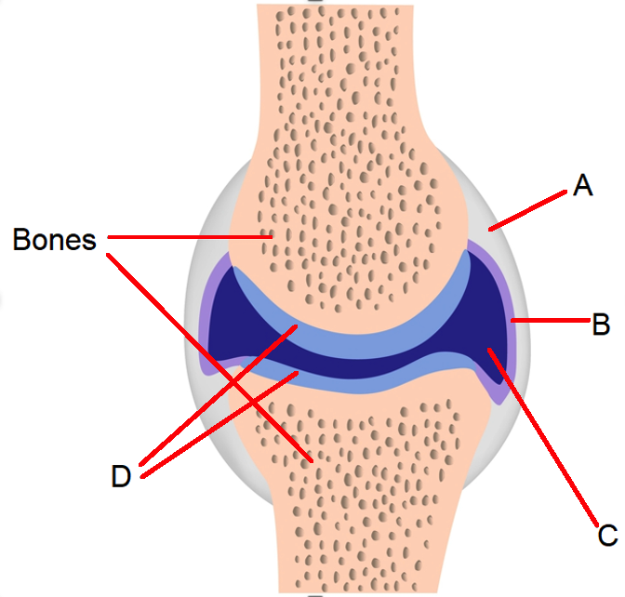

(d) Complete the table below, identifying the parts labelled in the diagram. (3 marks)

|  |  |
| --- | --- |
| **Description** | **Marks** |
| A - Capsule | 1 |
| B - Synovial membrane | 1 |
| C - Synovial fluid/cavity | 1 |
| **Total** | **3** |

(e) Describe structure of type of cartilage labelled at point D. (1 mark)

|  |  |
| --- | --- |
| **Description** | **Marks** |
| Contains many closely packed collagen fibres | 1 |
| **Total** | **1** |

(f) Name the condition that is characterised by the wearing away of the cartilage at a synovial joint and describe how this condition can be prevented and treated.

(3 marks)

|  |  |
| --- | --- |
| **Description** | **Marks** |
| Osteoarthritis | 1 |
| Prevent = avoid overuse overuse of the join/impact on joints/avoid any associated risk factor related to osteoarthritis | 1 |
| Treatment = medication for the pain/joint replacement surgery/physiotherapy | 1 |
| **Total** | **3** |

**Question 37** **(15 marks)**

The diagram below shows the structures of the human heart.

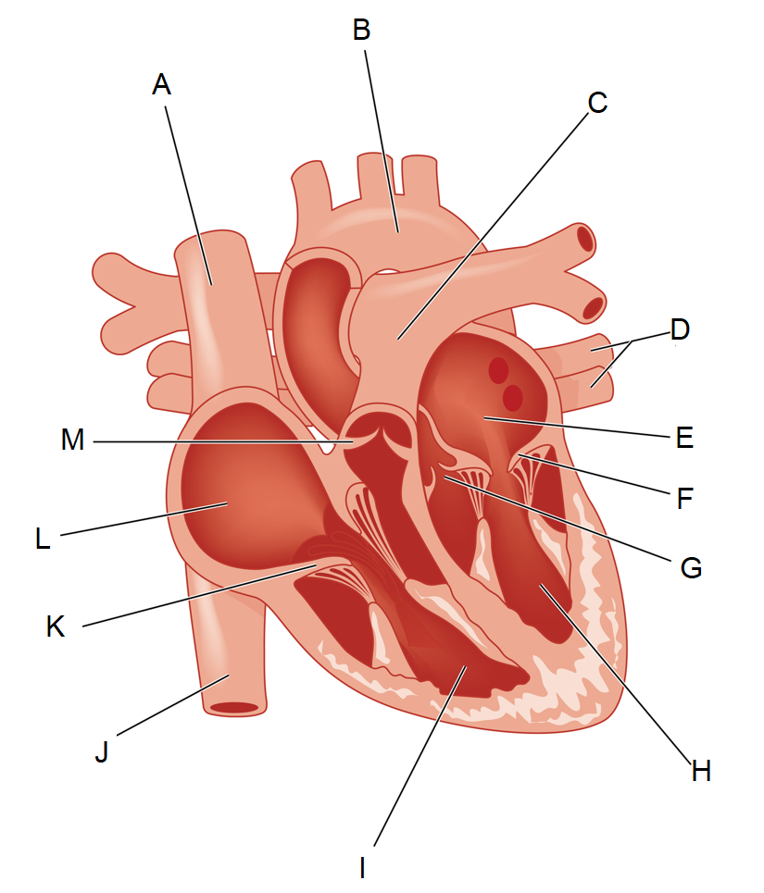

(a) Name the type of tissue that the heart is primarily comprised of, and describe the structure of this tissue. (3 marks)

|  |  |
| --- | --- |
| **Description** | **Marks** |
| Cardiac muscle | 1 |
| Made up of branched cells | 1 |
| Cells are striated | 1 |
| **Total** | **3** |

(b) Complete the table below, describing the function of the parts labelled in the diagram.

(3 marks)

|  |  |
| --- | --- |
| **Description** | **Marks** |
| A – carry blood from upper part of body to right atrium | 1 |
| B – carry blood to all parts of the body except the lungs | 1 |
| D – carry blood from lungs back to the left atrium | 1 |
| **Total** | **3** |

(c) Collectively outline the function and importance of the structures labelled F, G and K.

(3 marks)

|  |  |
| --- | --- |
| **Description** | **Marks** |
| To prevent the backflow of blood | 1 |
| Allowing the blood to travel in the right direction | 1 |
| Therefore oxygenated blood reaches its targets and deoxygenated blood can reach the lungs/therefore no mixing of oxygenated and deoxygenated blood (or similar answer about why it’s important) | 1 |
| **Total** | **3** |

During the foetal period of gestation the heart rate of the foetus can be monitored by a doctor or midwife. However, the foetus also relies on the connection with the mother through placenta and umbilical cord to aid in its circulatory system.

(d) Explain the role of the placenta and umbilical cord in aiding the circulatory system of the developing foetus. (4 marks)

|  |  |
| --- | --- |
| **Description** | **Marks** |
| Oxygen and nutrients are transported into foetal blood from mother’s blood through placenta | 1 |
| Umbilical vein carries blood from the placenta to the foetus | 1 |
| Enters the circulatory system of the foetus | 1 |
| Metabolic wastes from the foetus is transported back to placenta through umbilical arteries | 1 |
| **Total** | **4** |

(e) The placenta also releases hormones, including progesterone. Outline the role of progesterone in the menstrual cycle and suggest an explanation for why the placenta would secrete this hormone during pregnancy. (2 marks)

|  |  |
| --- | --- |
| **Description** | **Marks** |
| Progesterone maintains/thickens endometrium during menstrual cycle | 1 |
| May be necessary to maintain connection between placenta and uterus/so that labour is not initiated too early | 1 |
| **Total** | **2** |

**End of Section Two**

**Section Three: Extended answer 20% (40 Marks)**

**Unit 1**

**Question 38 (20 marks)**

Rhabdomyolysis is a condition where the muscle tissue is broken down and proteins enter the blood stream. This can lead to many complications, including an overproduction of urea and kidney failure.

(a) Describe the macroscopic and microscopic structure of skeletal muscle. (10 marks)

|  |  |
| --- | --- |
| **Description** | **Marks** |
| Muscle cells are held together in bundles/surrounded by perimysium | 1 |
| Connective tissues/epimysium holds the bundles together | 1 |
| Epimysium/connective tissue tapers at end of muscle to form tendons | 1 |
| Each muscle cell is an elongated cylinder with many nuclei | 1 |
| Each muscle cell contains a sarcolemma and sarcoplasm | 1 |
| Within sarcoplasm are myofibril threads | 1 |
| Each myofibril is made up of myofilaments | 1 |
| Thick filament is made up of myosin | 1 |
| Thin filaments is made up of actin | 1 |
| Myofilaments make up units called sarcomeres | 1 |
| **Total** | **10** |

(b) Describe and explain the role of the liver in the overproduction of urea caused by the breakdown of proteins. (6 marks)

|  |  |
| --- | --- |
| **Description** | **Marks** |
| Deamination occurs in the liver | 1 |
| Which is the breakdown of amino acids that make up proteins | 1 |
| Amino groups are removed from amino acids | 1 |
| Produces a carbohydrate and ammonia | 1 |
| Ammonia is very toxic | 1 |
| Therefore is converted into urea (hence the excess urea from the breakdown of proteins) | 1 |
| **Total** | **6** |

(c) Explain the effect of kidney failure on the chemical composition of body fluids. (4 marks)

|  |  |
| --- | --- |
| **Description** | **Marks** |
| Kidney is important for regulation of body fluids | 1 |
| It allows for reabsorption of water and other essential nutrients | 1 |
| And allows for excretion of metabolic wastes (through urine) | 1 |
| When kidneys fail the blood cannot be filtered and/or nutrients may be lost in the urine | 1 |
| **Total** | **4** |

**Question 39 (20 marks)**

Cellular respiration is one of many essential metabolic processes that occurs in all cells.

(a) Explain the role of ATP in the process of cellular respiration. (5 marks)

|  |  |
| --- | --- |
| **Description** | **Marks** |
| Energy released from cellular respiration can be stored in ATP | 1 |
| ADP/adenosine diphosphate is made up of two phosphates and adenosine | 1 |
| When energy is released from respiration a third phosphate bonds to ADP | 1 |
| This is a high energy bond and creates a molecule of ATP/adenosine triphosphate | 1 |
| The energy stored in ATP can now be released and used when needed by the cell | 1 |
| **Total** | **5** |

(b) Contrast anaerobic and aerobic respiration. (8 marks)

|  |  |
| --- | --- |
| **Description** | **Marks** |
| Any four of the following (1 mark for the anaerobic point and 1 mark for aerobic point for each): | |
| * Anaerobic respiration does not require oxygen * Aerobic respiration requires oxygen | 1-8 |
| * Anaerobic takes place in the cytosol * Aerobic takes place in the mitochondria |
| * Anaerobic produces pyruvate * Aerobic produces carbon dioxide and water |
| * Anaerobic releases enough energy for 2 ATP/can form up 2 ATP molecules from anaerobic respiration * Aerobic releases enough energy for up to 36/38 ATP/can form up to 36/38 ATP from aerobic respiration |
| * Anaerobic involves the process of glycolysis * Aerobic involves the Krebs cycle and electron transport system |
| **Total** | **8** |

(c) Explain how the functions of the digestive and circulatory system allow cellular respiration to take place in all cells in the body. (7 marks)

|  |  |
| --- | --- |
| **Description** | **Marks** |
| Digestive system: | |
| Breaks down the food we eat | 1 |
| Simple substances absorbed into blood | 1 |
| Include glucose necessary for anaerobic respiration | 1 |
| Plus other nutrients/lists examples needed for enzymes to function through cellular respiration | 1 |
| **Subtotal** | **4** |
| Circulatory system: | |
| Carries oxygen and glucose in the blood | 1 |
| Oxygen is essential aerobic respiration/glucose is essential for anaerobic respiration | 1 |
| Therefore supplying cells with the what needed to complete respiration | 1 |
| **Subtotal** | **3** |
| **Total** | **7** |

**Unit 2**

**Question 40 (20 marks)**

The production of identical daughter cells through the process of mitosis allows for growth, repair and replacement of tissues throughout our lifetime.

(a) Name and describe the four phases of mitosis. (10 marks)

|  |  |
| --- | --- |
| **Description** | **Marks** |
| Prophase | 1 |
| * Nucleolus disappears * Nuclear membrane breaks down * Centrioles migrate to poles * Chromosomes appear as two chromatids/chromatin condenses into chromosomes * Spindle forms from microtubules | 1-3 |
| Metaphase | 1 |
| * Chromosomes line up at the equator of the cell | 1 |
| Anaphase | 1 |
| * Centromeres divide/degenerate * Chromosomes move to opposite ends of spindle | 1 |
| Telophase | 1 |
| * Spindle disappears * Nuclear membranes and nucleoli form * Centrioles divide * Chromosomes uncoil * Cytokinesis begins | 1-3 |
| **Total** | **12** |

(b) Describe what is meant by the term cancer and explain how the development of malignant tumours can be detrimental to the functioning of normal body tissues.

(5 marks)

|  |  |
| --- | --- |
| **Description** | **Marks** |
| When cells divide uncontrollably this is cancer | 1 |
| Cancer cells do not differentiate into normal tissue cells | 1 |
| They form a tumour/a mass of cells called a tumour | 1 |
| Tumours grow at a rapid rate | 1 |
| Therefore normal body tissues cannot get supply of nutrients/cancerous cells ‘take over’ the normal body cells/tumour exerts pressure on organs and surrounding tissues/there can be a build up of wastes in the area | 1 |
| **Total** | **5** |

(c) Describe how cervical screening tests, breast screening and blood tests have made early detections of some cancers possible. (3 marks)

|  |  |
| --- | --- |
| **Description** | **Marks** |
| Cervical screening tests identifies abnormal cells before they become cancerous | 1 |
| Breast screening uses an X-ray to get a picture of the breasts and identify tumours | 1 |
| Some blood tests can identify abnormalities that can be linked to bowel and prostate cancer | 1 |
| **Total** | **3** |

**Question 41 (20 marks)**

After 10 months of trying to fall pregnant a couple were able to determine the establishment of a successful pregnancy through a standard pregnancy test for levels of human chorionic gonadotropin.

(a) Outline the path of the sperm from the epididymis to the point where conception occurs. Include in your answer a description of the process of fertilisation.

(10 marks)

|  |  |
| --- | --- |
| **Description** | **Marks** |
| Pathway of sperm: | |
| * Travels through vas deferens * Seminal vesicles release sugar-rich fluid to combine with sperm * Prostate releases alkaline fluid * Semen travels through urethra and exits body * Semen deposited into vagina * Sperm pass through cervix and uterus * To fallopian tube where they meet ovum | 1-6 |
| **Subtotal** | **6** |
| Fertilisation: | |
| Enzyme in acrosome breaks down corona radiata/zona pellucida | 1 |
| Nucleus of the sperm enters the ovum | 1 |
| The forms a membrane which prevents entry of other sperm | 1 |
| Nucleus of sperm fuses with nucleus of ovum (zygote is formed) | 1 |
| **Subtotal** | **4** |
| **Total** | **10** |

The couple were informed by a health professional that they were in a high-risk category for genetic and physical abnormalities in their unborn child. They were advised to undergo a series of tests.

(b) Describe how the following allow for screening of the embryo or foetus during early development: (10 marks)

* Blood test (of the mother’s blood)
* Ultrasound
* Amniocentesis

|  |  |
| --- | --- |
| **Description** | **Marks** |
| Blood test | |
| Some of the baby’s DNA passes into the mother’s blood | 1 |
| A blood test of the mother’s blood can have the genetics of the foetus tested | 1 |
| This helps determine the chances (but does not diagnose) of certain genetic disorders | 1 |
| **Subtotal** | **3** |
| Ultrasound: | |
| A probe is placed on the abdomen of pregnant woman | 1 |
| High frequency sound waves are reflected by foetus and produce image | 1 |
| This image can be used to monitor growth and development of the foetus | 1 |
| Can monitor for physical birth defects | 1 |
| **Subtotal** | **4** |
| Amniocentesis: | |
| Ultrasound guides needle through abdominal wall into amniotic sac | 1 |
| Amniotic fluid is removed | 1 |
| Foetal cells in the fluid can be tested for genetic abnormalities | 1 |
| **Subtotal** | **3** |
| **Total** | **10** |

**End of questions**

**ACKNOWLEDGEMENTS**

**Question 5 – 7** Adapted from: Radu, B. (n.d) [Animal cell diagram]. Retrieved from <https://www.dreamstime.com/stock-illustration-animal-cell-structure-white-background-vector-illustration-helpful-education-schools-image65486924>

**Questions 14 – 15** Adapted from: Designua (n.d.) [Structure of a Nephron diagram]. Retrieved from <https://www.dreamstime.com/structure-nephron-formation-urine-liquid-enters-to-glomerulus-browman-s-capsule-goes-down-loop-henle-collecting-image102564238>

**Question 28 – 30** Adapted from: Georghiou, C. (n.d.) [Digestive Tract System Illustration]. Retrieved from <https://www.dreamstime.com/stock-illustration-digestive-tract-system-illustration-human-alimentary-canal-labels-black-white-image84348384>

**Question 32**  Adapted from: Designua (n.d.) [Mechanisms for the transport of ions and molecules across cell diagram]. Retrieved from <https://www.dreamstime.com/stock-illustration-mechanisms-transport-ions-molecules-across-cell-m-membranes-types-channel-membrane-simple-diffusion-image77366193>

**Question 34** Adapted from: Desginua (n.d.) [Spermatogenesis and Oogenesis diagram]. Retrieved from <https://www.dreamstime.com/stock-illustration-spermatogenesis-oogenesis-ovogenesis-creation-ovum-female-form-gametogenesis-male-image53839558#_>

**Question 36** Adapted from: Alila07 (n.d.) [Synovial joint structure diagram]. Retrieved from: <https://www.dreamstime.com/stock-images-synovial-joint-structure-image22042874>

**Question 37** Adapted from: Legger (n.d.) [The heart diagram]. Retrieved from: <https://www.dreamstime.com/stock-illustration-heart-cross-section-showing-major-vessels-named-valves-created-adobe-illustrator-contains-gradient-meshes-image54204327>